**Trumbull Parks and Recreation**

**K-3 Basketball**

**Rules and Regulations**

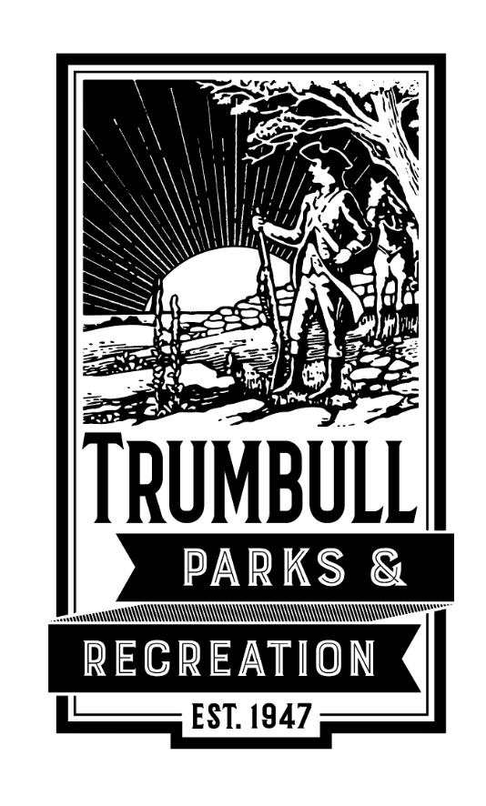

**Last updated 12/4/24.**

**Schedule**

Teams will have 25 minutes of practice time and 30 minutes of scrimmages. Coaches are encouraged to assist all players in learning the rules and developing basic skills. Score will not be kept in this league as the focus will be on developing fundamental skills and knowledge of the game.

**Please remember:**

* **Food and drinks are prohibited in the gyms.**
* **Alcohol, tobacco products and electronic nicotine delivery devices are prohibited on school grounds.**
* **Anyone found damaging Trumbull Park & Rec or Board of Education property will be responsible for all repair/replacement costs.**
* **Do not bounce basketballs in the hallways.**
* **Do not wander around the school. Stay in the area immediately surrounding the gym.**
* **Each school has their own specific rules or regulations. Please ask the gym attendant for more information.**

**NO JEWELRY MAY BE WORN WHILE PLAYING. Taping over earrings is NOT acceptable.**

**Grades K -3 will follow normal basketball rules except…**

1. Playing Rules
   1. Game will be played on an 8 ft. basket, with a junior size ball (27.5 in).
   2. 25 minute Practice followed by a 30 minute 3x3 scrimmage. Court time cannot extend past 1 hour/team. Bye weeks will not include a scrimmage.
   3. Each team will have two 30-second time-outs (only timeouts due to player safety are allowed after these two)
   4. All players must receive equal playing time.
   5. Substitutions can be made at any time during dead ball situations. Ball out of bounds, violation, foul, etc.
   6. Scrimmages will begin with one team inbounding the ball at half court and possession awarded to the other team during the next ‘held ball.’ If coaches feel their players are ready for a jump ball and both coaches agree. The game may begin with a traditional jump ball.
   7. All teams must have at least four players to begin a game (1 Substitute).
   8. NO JEWELRY CAN BE WORN WHILE PLAYING. Taping over earrings is NOT acceptable.
2. Offense
   1. Offense has 10 seconds to advance ball past midcourt.
   2. There will be many double dribbles and traveling in this league. Discretion is left to the coaches on when to call this. First violations do not result in turnovers. Team regains possession by inbounding the ball at the closets spot.
3. Defense
   1. No double teaming. Man-to-man defense only.
   2. **No full court press.** Defense must retreat to the frontcourt before starting to defend.
   3. The defense cannot steal the ball from the ball handler; steals only on the pass.
   4. No shot blocking; hands can be straight up and result in a block. Teach kids to stand with hands straight up when guarding shot. Hands out to the side when guarding dribbler.

**Basketball Rules**

Basketball is broken down into 10 rules, however there are many interpretations of rules that can be confusing. Many rules are also forgotten by players especially at a young age for example the three second rule in the offense lane.

Coaches should start by teaching the main fouls and violations children need to understand in order for game play. Instilling fundamentals at this age will help to develop players with strong skills and knowledge as they grow.

Some of the most common fouls/violations at this age will be with dribbling and fouling other players. Drills should focus on improving the player’s ability to handle the ball and play defense.

Here are some of the basic concepts to teach players:

**Scoring.** No three pointers. All shots are worth 2 points. A foul shot is worth 1 point.

**Tip-off/jump ball.** Coaches should discuss if they want to have a jump ball to start the game. If a jump ball is held, the team that does not gain possession off the tip will get the possession arrow and be awarded the ball on the next ‘held ball.’ The arrow switched back and forth with each ‘held ball.’

**Dribbling violations.** There will be many at this age group. Players are not allowed to dribble the ball with both hands simultaneously. In addition, once a dribble has stopped, a player may not begin a new dribble. There only options are to pass or shoot. Players are not allowed to run with the ball. Once stopped, players can pivot on one foot by keeping on the same spot on the floor. If the pivot foot is lifted before an attempted pass or shot, it is a travel.

**Personal fouls.** A player must remain in control of himself or herself and will draw a foul for actions such as hitting, holding pushing, slapping and tripping. Fouls can be called on both the offense and defense. There will be no 5 foul limit for disqualification however coaches should use discretion if a player continuously fouls, they should be removed from the game for a short period.

**Charging/blocking.** A charge is an offensive foul that is committed when a player pushes or runs over a defensive player in legal guarding position. The ball is awarded to the defense. A defender must establish position in front of the offensive player. If they do not and contact is made, it is a blocking foul. Ask yourself in this situation, who caused the contact?

**Foul shot violation.** Nobody can enter the foul lane on a free throw until the ball hits the rim. Shooters may jump over the line but not go in for a rebound until the ball hits the rim.

**Ten-second violation.** When moving the basketball up from its backcourt, a boys’ basketball team has 10 seconds to get the ball over the midcourt line. If the offense commits the violation, the ball is awarded to the defense. This rule is not used in all levels of girls' basketball.

**Backcourt violation.** Once the offense moves the basketball past the midcourt line, it cannot allow it to go back across the line during its possession. If the offense commits this violation, the ball is awarded to the defense. If the defense knocks the ball over the sideline or baseline during the possession, the offense can inbounds the ball into the backcourt and collect it again.

**Three-second rule.** An offensive player cannot stand in the lane (also known as the key or paint) for more than three seconds. If the offense commits the violation, the ball is awarded to the defense. With grades k-3, a verbal warning should be used and allow for 5 seconds before making the call.

**Five-second violation.** On an inbounds play, the passer must pass the basketball within five seconds or it will be awarded to the defense.

These rules should be reinforced throughout practices and can be done so through quizzes, drills and practice.

In addition, players should know the playing court.

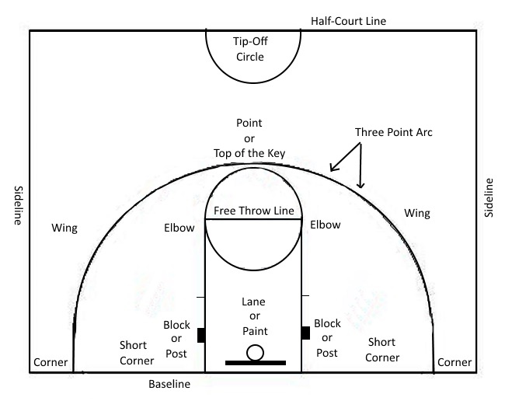BASKETBALL COURT:

**Fouls and Violations**

**FOULS**

**Personal fouls:** Personal fouls include any type of illegal physical contact.

• Hitting

• Pushing

• Slapping

• Holding

• Illegal pick/screen -- when an offensive player is moving. When an offensive player sticks out a limb and makes physical contact with a defender in an attempt to block the path of the defender.

Personal foul penalties: If a player is shooting while a being fouled, then he gets two free throws if his shot doesn't go in, but only one free throw if his shot does go in.

**Charging -** offensive foul that is committed when a player, in control of the ball, pushes or runs over a defensive player. The ball is given to the defense.

**Blocking -** illegal personal contact resulting from a defender not establishing position in time to prevent an opponent's drive to the basket.

**Flagrant foul -** Violent contact with an opponent. This includes hitting, kicking, and punching. Player should be sat down immediately for the rest of the game.

**Intentional foul -** When a player makes physical contact with another player making no attempt at the ball. It is a judgment call for the officials.

**Technical foul -** A player or a coach can commit this type of foul and is an unsporting type foul. Foul language, obscenity, obscene gestures, and even arguing can be considered a technical foul, as can technical details regarding filling in the scorebook improperly or dunking during warm-ups.

Inbounds. If fouled while not shooting, the ball is given to the team the foul was committed upon at the nearest spot to the foul, out of bounds, and have 5 seconds to pass the ball onto the court.

**VIOLATIONS**

**Traveling -** Taking more than 'a step and a half' without dribbling the ball is traveling. Moving your pivot foot once you've stopped dribbling is traveling. Carrying, when a player holds the ball with one or two hands and walks, is also a travel.

**Double Dribble -** Dribbling the ball with both hands on the ball at the same time or picking up the dribble and then dribbling again is a double dribble.

**Held ball -** Often, two or more opposing players will gain possession of the ball at the same time. In order to avoid a prolonged and/or violent tussle, the referee stops the action and awards the ball to the team that has the possession arrow.

**Backcourt -** Once the offense has brought the ball across the mid-court line, they cannot go back across the line during possession. If they do, the ball is awarded to the other team to pass inbounds. If the ball is tipped back by the defense, the offense can retrieve the ball with no violation.

**5 Second Violation –** A player has 5 seconds to inbound the ball from out of bounds. If 5 seconds elapses, ball awarded to other team.

**Player Positions**

**Center –** Five Position – A player that will play down low on the block and in the lane on defense. A taller player who can rebound and is the last defender on offensive drives.

**Power Forward –** Four Positon - Your next tallest players will most likely be your forwards. While a forward may be called upon to play under the hoop, they may also be required to operate in the wings and corner areas.

**Small Forward –** Three Position – This is a player with size and speed that can help rebound but shoot as well.

**Shooting Guard –** Two Position – This player should be able to defend players away from the basket and have speed to stay in front. They should also be able to dribble and handle the ball.

**Point Guard –** One position – This player will be the primary ball handler and responsible for bringing the ball up the court. They should be able to dribble, pass and stay in front on defense.